Aditya University

Database Management Systems (2501IT05)

Batch – 8 Capstone Project

Project Title :

Hospital Management System using Relational Database Management System

Team:
Name | Roll number
Charan Sai Venkata Raju Katta | 25B11CS149
Svova Moreblessing | 25B11CSA74
Dangeti Praneela | 25B11CS209
Nadipineni Harshavardhan | 25B11CS243

Problem Statement:
Many hospitals continue to rely on manual record-keeping or fragmented systems to manage patient information, doctor details, appointments, admissions, prescriptions, and billing. As the number of patients increases, maintaining accurate and consistent records becomes more challenging. Manual processes are time-consuming, increase the possibility of data duplication and human error, and make it difficult to retrieve information quickly. In addition, the lack of a centralized database can lead to inconsistencies in patient records, appointment scheduling issues, and delays in administrative tasks.
This project aims to design a Hospital Management System database that centralizes and organizes hospital information in a structured relational database. The system is intended to improve data organization, support efficient information retrieval, maintain data integrity through relational design, and provide a reliable foundation for managing hospital operations.

Objectives:
The primary objective of this project is to design and develop a centralized Hospital Management System database that efficiently manages hospital information and supports the storage, retrieval, and maintenance of hospital records using a relational database management system.
The specific objectives of the project are:
- To design a centralized database for managing patient, doctor, department, appointment, admission, prescription, billing, and payment information.
- To organize hospital data efficiently by establishing proper relationships between different entities using a relational database model.
- To minimize data redundancy and maintain data integrity through the implementation of primary keys, foreign keys, and appropriate database constraints.
- To facilitate efficient storage, retrieval, updating, and deletion of hospital records using SQL operations.
- To support essential hospital activities such as patient registration, doctor management, appointment scheduling, patient admissions, prescription management, and billing.
- To enable quick and accurate retrieval of information by implementing SQL queries, joins, aggregate functions, and database views.
- To develop a scalable and well-structured database design that can be integrated with a software application in the future.
- To provide a reliable database system that improves record management, enhances data consistency, and supports efficient hospital administration.
Entities, Attributes, Primary Keys and Foreign Keys:

Entity 1: Department

Purpose: Stores information about hospital departments.

Attribute | Description
Department_ID (Primary key) | Unique department ID
Department_Name | Cardiology, Neurology, etc.
Department_Location | Floor/Block
Contact_Number | Department contact number

Entity 2: Doctor

Purpose: Stores doctor details.

Attribute | Description
Doctor_ID (Primary Key) | Unique doctor ID
Name | Doctor's full name
Gender | Male/Female/Other
Phone_Number | Contact number
Email | Official email
Specialization | Cardiologist, Dentist, etc.
Qualification | MBBS, MD, etc.
Department_ID (Foreign Key) | Department where the doctor works

Entity 3: Patient

Purpose: Stores patient information.

Attribute | Description
Patient_ID (Primary Key) | Unique patient ID
Name | Patient's full name
Date_of_Birth | Date of birth
Gender | Male/Female/Other
Blood_Group | Blood group
Phone_Number | Contact number
Address | Residential address
Emergency_Contact | Emergency contact number

Entity 4: Appointment

Purpose: Records appointments between patients and doctors.

Attribute | Description
Appointment_ID (Primary Key) | Unique appointment ID
Patient_ID (Foreign Key) | Patient
Doctor_ID (Foreign Key) | Doctor
Appointment_Date | Appointment date
Appointment_Time | Appointment time
Appointment_Status | Scheduled, Completed, Cancelled

Entity 5: Room

Purpose: Stores hospital room details.

Attribute | Description
Room_ID (Primary Key) | Unique room ID
Room_Number | Room number
Room_Type | General, ICU, Private
Room_Status | Available, Occupied

Entity 6: Admission

Purpose: Stores patient admission details.

Attribute | Description
Admission_ID (Primary Key) | Unique admission ID
Patient_ID (Foreign Key) | Patient admitted
Room_ID (Foreign Key) | Assigned room
Admission_Date | Date admitted
Discharge_Date | Date discharged
Admission_Status | Admitted/Discharged

Entity 7: Prescription

Purpose: Stores prescriptions issued by doctors.

Attribute | Description
Prescription_ID (Primary Key) | Unique prescription ID
Appointment_ID (Foreign Key) | Related appointment
Doctor_ID (Foreign Key) | Prescribing doctor
Patient_ID (Foreign Key) | Patient
Prescription_Date | Date issued
Doctor_Remarks | Doctor's remarks

Entity 8: Prescription_Details

Purpose: Stores the details of medicines prescribed in each prescription, including dosage, frequency, duration, and special instructions. It acts as a bridge between the Prescription and Medicine entities.

Attribute | Description
Prescription_Detail_ID (Primary Key) | Unique prescription detail ID
Prescription_ID (Foreign Key) | Related prescription
Medicine_ID (Foreign Key) | Prescribed medicine
Dosage | Dosage of medicine (e.g., 500 mg)
Frequency | Number of times medicine should be taken
Duration | Number of days medicine should be taken
Instructions | Special instructions (e.g., After Food)

Entity 9: Medicine

Purpose: Stores medicine information.

Attribute | Description
Medicine_ID (Primary Key) | Unique medicine ID
Medicine_Name | Name of medicine
Category | Tablet, Syrup, Injection
Unit_Price | Price per unit
Stock_Quantity | Available stock

Entity 10: Bill

Purpose: Stores billing information.

Attribute | Description
Bill_ID (Primary Key) | Unique bill ID
Patient_ID (Foreign Key) | Patient
Admission_ID (Foreign Key) | Related admission (if any)
Bill_Date | Date of bill
Total_Amount | Total amount
Payment_Status | Paid/Pending

Entity 11: Payment

Purpose: Stores payment details.

Attribute | Description
Payment_ID (Primary Key) | Unique payment ID
Bill_ID (Foreign Key) | Related bill
Payment_Date | Date of payment
Payment_Method | Cash, Card, UPI
Amount_Paid | Amount paid

ER – Diagram:
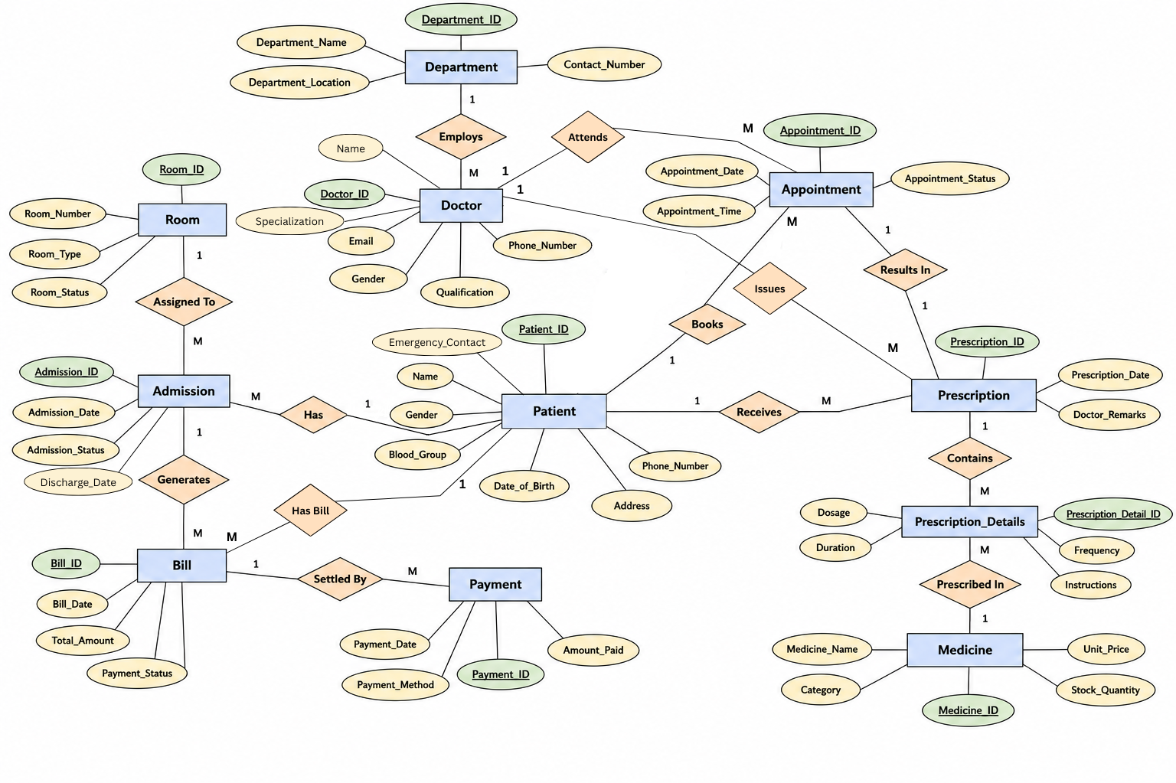
Relational Database Schema:
The relational database schema defines the logical structure of the Hospital Management System database. It represents the entities identified during the database design process as relational tables and specifies their attributes, primary keys, and foreign keys.
Each relation represents an entity in the hospital management system. Primary keys are used to uniquely identify records in each relation, while foreign keys establish relationships between related relations and maintain referential integrity.
The relational schema of the proposed Hospital Management System consists of 11 relations:
- Department
- Doctor
- Patient
- Appointment
- Room
- Admission
- Prescription
- Prescription_Details
- Medicine
- Bill
- Payment
The schema is derived from the entities, attributes, primary keys, and foreign keys defined in the project design.

Relation 1: Department

DEPARTMENT
(
DEPARTMENT_ID,
DEPARTMENT_NAME,
DEPARTMENT_LOCATION,
CONTACT_NUMBER
)

- Primary Key: DEPARTMENT_ID

Relation 2: Doctor

DOCTOR
(
DOCTOR_ID,
NAME,
GENDER,
PHONE_NUMBER,
EMAIL,
SPECIALIZATION,
QUALIFICATION,
DEPARTMENT_ID
)
- Primary Key: DOCTOR_ID
- Foreign Key: DEPARTMENT_ID → DEPARTMENT(DEPARTMENT_ID)

Relation 3: Patient

PATIENT
(
PATIENT_ID,
NAME,
DATE_OF_BIRTH,
GENDER,
BLOOD_GROUP,
PHONE_NUMBER,
ADDRESS,
EMERGENCY_CONTACT
)

- Primary Key: PATIENT_ID

Relation 4: Appointment

APPOINTMENT
(
APPOINTMENT_ID,
PATIENT_ID,
DOCTOR_ID,
APPOINTMENT_DATE,
APPOINTMENT_TIME,
APPOINTMENT_STATUS
)

- Primary Key: APPOINTMENT_ID
- Foreign Keys:
  - PATIENT_ID → PATIENT(PATIENT_ID)
  - DOCTOR_ID → DOCTOR(DOCTOR_ID)
Relation 5: Room

ROOM
(
ROOM_ID,
ROOM_NUMBER,
ROOM_TYPE,
ROOM_STATUS
)

- Primary Key: ROOM_ID

Relation 6: Admission

ADMISSION
(
ADMISSION_ID,
PATIENT_ID,
ROOM_ID,
ADMISSION_DATE,
DISCHARGE_DATE,
ADMISSION_STATUS
)

- Primary Key: ADMISSION_ID
- Foreign Keys:
  - PATIENT_ID → PATIENT(PATIENT_ID)
  - ROOM_ID → ROOM(ROOM_ID)

Relation 7: Prescription

PRESCRIPTION
(
PRESCRIPTION_ID,
APPOINTMENT_ID,
DOCTOR_ID,
PATIENT_ID,
PRESCRIPTION_DATE,
DOCTOR_REMARKS
)

- Primary Key: PRESCRIPTION_ID
- Foreign Keys:
  - APPOINTMENT_ID → APPOINTMENT(APPOINTMENT_ID)
  - DOCTOR_ID → DOCTOR(DOCTOR_ID)
  - PATIENT_ID → PATIENT(PATIENT_ID)

Relation 8: Prescription_Details

PRESCRIPTION_DETAILS
(
PRESCRIPTION_DETAIL_ID,
PRESCRIPTION_ID,
MEDICINE_ID,
DOSAGE,
FREQUENCY,
DURATION,
INSTRUCTIONS
)

- Primary Key: PRESCRIPTION_DETAIL_ID
- Foreign Keys:
  - PRESCRIPTION_ID → PRESCRIPTION(PRESCRIPTION_ID)
  - MEDICINE_ID → MEDICINE(MEDICINE_ID)

Relation 9: Medicine

MEDICINE
(
MEDICINE_ID,
MEDICINE_NAME,
CATEGORY,
UNIT_PRICE,
STOCK_QUANTITY
)

- Primary Key: MEDICINE_ID

Relation 10: Bill

BILL
(
BILL_ID,
PATIENT_ID,
ADMISSION_ID,
BILL_DATE,
TOTAL_AMOUNT,
PAYMENT_STATUS
)

- Primary Key: BILL_ID
- Foreign Keys:
  - PATIENT_ID → PATIENT(PATIENT_ID)
  - ADMISSION_ID → ADMISSION(ADMISSION_ID)

Relation 11: Payment

PAYMENT
(
PAYMENT_ID,
BILL_ID,
PAYMENT_DATE,
PAYMENT_METHOD,
AMOUNT_PAID
)

- Primary Key: PAYMENT_ID
- Foreign Key: BILL_ID → BILL(BILL_ID)

Relationship Cardinality:
The relationships between the entities in the Hospital Management System are defined using cardinality, which specifies how many instances of one entity can be associated with instances of another entity. The cardinality of each relationship is identified as One-to-One (1:1), One-to-Many (1:M), or Many-to-One (M:1) based on the requirements of the system.
The following table describes the relationships between the entities and their corresponding cardinalities in the proposed Hospital Management System.

S.No. | Entity 1 | Relationship | Entity 2 | Cardinality | Meaning
1 | Department | Employs | Doctor | 1 : M | One department can employ many doctors, while each doctor belongs to one department.
2 | Room | Assigned To | Admission | 1 : M | One room can be assigned to many admissions, while each admission is assigned to one room.
3 | Patient | Has | Admission | 1 : M | One patient can have many admissions, while each admission belongs to one patient.
4 | Admission | Generates | Bill | 1 : M | One admission can generate many bills, while each bill is associated with one admission.
5 | Bill | Settled By | Payment | 1 : M | One bill can have multiple payments, while each payment is associated with one bill.
6 | Patient | Books | Appointment | 1 : M | One patient can book many appointments, while each appointment belongs to one patient.
7 | Doctor | Attends | Appointment | 1 : M | One doctor can attend many appointments, while each appointment is associated with one doctor.
8 | Patient | Receives | Prescription | 1 : M | One patient can receive many prescriptions, while each prescription belongs to one patient.
9 | Doctor | Issues | Prescription | 1 : M | One doctor can issue many prescriptions, while each prescription is issued by one doctor.
10 | Appointment | Results In | Prescription | 1 : 1 | One appointment results in one prescription, and one prescription is associated with one appointment.
11 | Prescription | Contains | Prescription_Details | 1 : M | One prescription can contain many prescription details, while each prescription detail belongs to one prescription.
12 | Medicine | Prescribed In | Prescription_Details | 1 : M | One medicine can appear in many prescription details, while each prescription detail refers to one medicine.
13 | Patient | Has Bill | Bill | 1 : M | One patient can have multiple bills, while each bill belongs to one patient.

